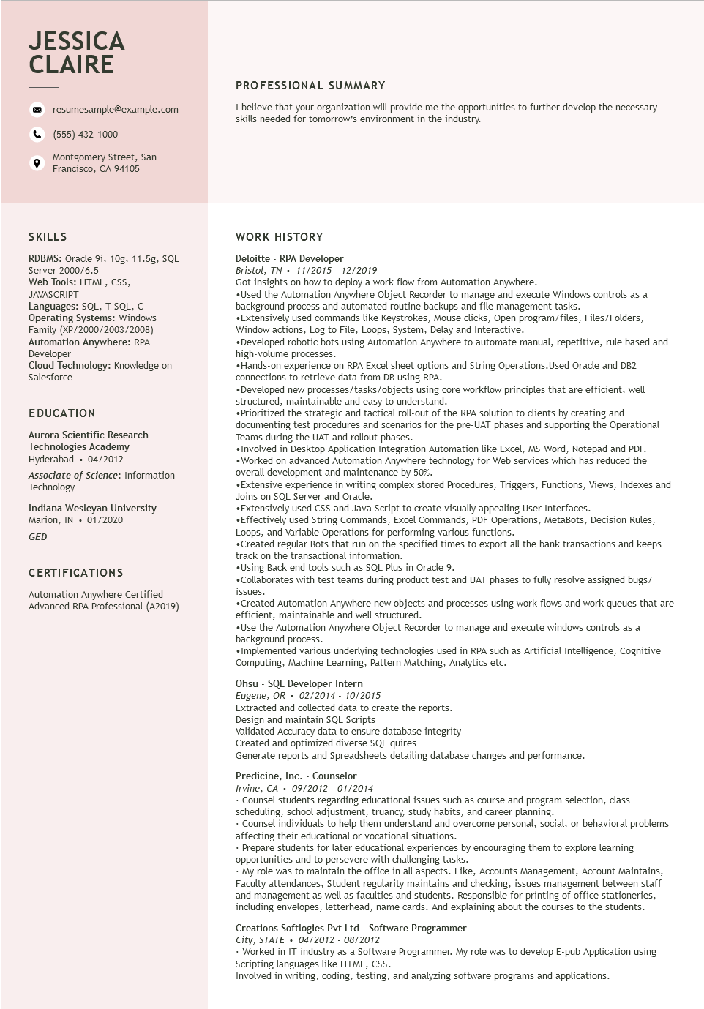
JESSICA CLAIRE
resumesample@example.com
(555) 432-1000
Montgomery Street, San Francisco, CA 94105
PROFESSIONAL SUMMARY
I believe that your organization will provide me the opportunities to further develop the necessary skills needed for tomorrow's environment in the industry.
SKILLS
RDBMS: Oracle 9i, 10g, 11.5g, SQL
Server 2000/6.5
Web Tools: HTML, CSS,
JAVASCRIPT
Languages: SQL, T-SQL, C Operating Systems: Windows Family (XP/2000/2003/2008) Automation Anywhere: RPA Developer
Cloud Technology: Knowledge on Salesforce
EDUCATION
Aurora Scientific Research Technologies Academy Hyderabad. 04/2012
Associate of Science: Information Technology
Indiana Wesleyan University Marion, IN. 01/2020
GED
CERTIFICATIONS
Automation Anywhere Certified Advanced RPA Professional (A2019)
WORK HISTORY
Deloitte - RPA Developer
Bristol, TN 11/2015 - 12/2019
Got insights on how to deploy a work flow from Automation Anywhere.
•Used the Automation Anywhere Object Recorder to manage and execute Windows controls as a background process and automated routine backups and file management tasks.
•Extensively used commands like Keystrokes, Mouse clicks, Open program/files, Files/Folders, Window actions, Log to File, Loops, System, Delay and Interactive.
•Developed robotic bots using Automation Anywhere to automate manual, repetitive, rule based and high-volume processes.
•Hands-on experience on RPA Excel sheet options and String Operations. Used Oracle and DB2 connections to retrieve data from DB using RPA.
•Developed new processes/tasks/objects using core workflow principles that are efficient, well structured, maintainable and easy to understand.
•Prioritized the strategic and tactical roll-out of the RPA solution to clients by creating and documenting test procedures and scenarios for the pre-UAT phases and supporting the Operational Teams during the UAT and rollout phases.
•Involved in Desktop Application Integration Automation like Excel, MS Word, Notepad and PDF. •Worked on advanced Automation Anywhere technology for Web services which has reduced the overall development and maintenance by 50%.
•Extensive experience in writing complex stored Procedures, Triggers, Functions, Views, Indexes and Joins on SQL Server and Oracle.
•Extensively used CSS and Java Script to create visually appealing User Interfaces.
•Effectively used String Commands, Excel Commands, PDF Operations, MetaBots, Decision Rules, Loops, and Variable Operations for performing various functions.
•Created regular Bots that run on the specified times to export all the bank transactions and keeps track on the transactional information.
•Using Back end tools such as SQL Plus in Oracle 9.
•Collaborates with test teams during product test and UAT phases to fully resolve assigned bugs/ issues.
•Created Automation Anywhere new objects and processes using work flows and work queues that are efficient, maintainable and well structured.
•Use the Automation Anywhere Object Recorder to manage and execute windows controls as a background process.
•Implemented various underlying technologies used in RPA such as Artificial Intelligence, Cognitive Computing, Machine Learning, Pattern Matching, Analytics etc.
Ohsu - SQL Developer Intern
Eugene, OR 02/2014 - 10/2015
Extracted and collected data to create the reports.
Design and maintain SQL Scripts
Validated Accuracy data to ensure database integrity
Created and optimized diverse SQL quires
Generate reports and Spreadsheets detailing database changes and performance.
Predicine, Inc. - Counselor
Irvine, CA
09/2012 - 01/2014
• Counsel students regarding educational issues such as course and program selection, class scheduling, school adjustment, truancy, study habits, and career planning.
Counsel individuals to help them understand and overcome personal, social, or behavioral problems affecting their educational or vocational situations.
•Prepare students for later educational experiences by encouraging them to explore learning opportunities and to persevere with challenging tasks.
• My role was to maintain the office in all aspects. Like, Accounts Management, Account Maintains, Faculty attendances, Student regularity maintains and checking, issues management between staff and management as well as faculties and students. Responsible for printing of office stationeries, including envelopes, letterhead, name cards. And explaining about the courses to the students.
Creations Softlogies Pvt Ltd - Software Programmer
City, STATE⚫ 04/2012 - 08/2012
•Worked in IT industry as a Software Programmer. My role was to develop E-pub Application using Scripting languages like HTML, CSS.
Involved in writing, coding, testing, and analyzing software programs and applications.

